Seaweed Identification and Pressing

Topic: Art and Anatomy

Time: 1 ½ hours – low tide

Materials: large Tupperware containers, dissection trays, herbarium paper, cardboard, blotting paper, wax paper, pencils, seaweed field guides, plant presses & straps.

Goal: Learn some of the dominant macroalgae species in the Gulf of Maine. Learn the difference between plants and macroalgae. Get creative with making seaweed art!

Notes to Instructor:
Need access to the intertidal zone to collect seaweed. Please follow all local regulations when collecting seaweed. Maine resources are linked below.

Introduction
- Seaweed are not true plants, they are macroalgae, which belong to the kingdom Chromista. Unlike true plants, they do not have a vascular system, but they do photosynthesize!
- What are the 3 main groups of seaweed? Green (chlorophyta), Brown (phaeophyta), and Red (rhodophyta). While these groups are named after colors, sometimes the colors can be deceiving. Brown seaweeds often look green, and red seaweed can look brown.
- Looking around on the rocks, what color do you think this seaweed is? Fucus and Ascophyllum are both brown seaweeds and dominated the intertidal zone in the Gulf of Maine
- Seaweed comes in different morphologies, like filamentous, sheets, and blades, but most of them have a basic structure.
  - The holdfast is what attaches the seaweed to rock or any hard substrate. The “stem” is called the stipe, and the leafy like structure is called the blade. Some have air bladders called pneumatophores.
- Why would algae want air bladders? To be closer to the surface to get light to photosynthesize!
- Is seagrass a type of seaweed? No! Seagrasses are vascular, flowering plants. They have root systems called rhizomes that help them stabilize as the tides and waves wash in and out.
- Do we eat it? Yes! Seaweed has many minerals and nutrients that are essential for a healthy diet.

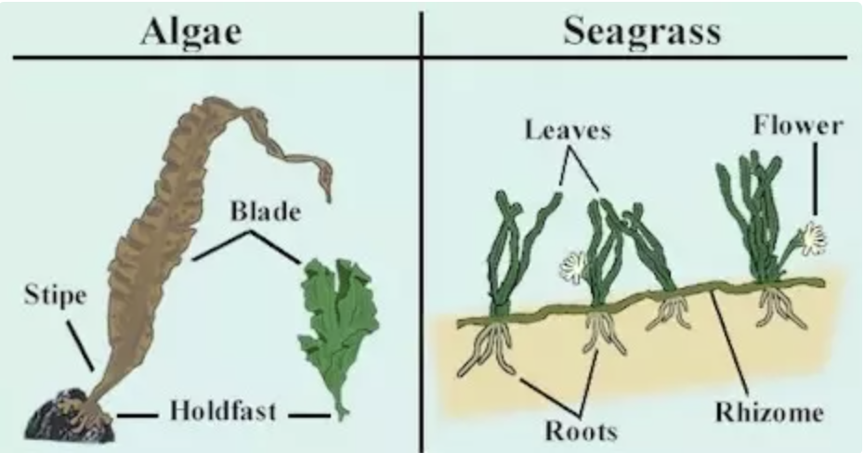
Activity:
- Separate students into groups of 3-4 and give them large Tupperwares to collect as many unique seaweed species as possible. Ideally, each group finds at least one green, brown, and red specimen. Allow ~15-20 minutes for searching.
- Once out of the intertidal, give each group a seaweed press, herbarium paper, blotting paper, a roll of wax paper, pencils, ID guides, and cardboard.
- Have them identify their specimens before pressing them, and write the species name and their name on the back of their herbarium paper. Some species require a microscope to properly ID.
- Explain how to press.
  - It’s like a sandwich, cardboard→blotting paper→herbarium paper →specimen→wax paper→blotting paper→cardboard. Multiple specimens can be piled into the same press if each individual has their own ‘sandwich’, starting and ending with cardboard. Seaweed slime acts as a natural glue and will stick to the paper when dry.
  - With finer seaweed you need to submerge your herbarium paper in water with the sample so the seaweed can spread out as it naturally would in the water (use the dissecting trays for this). Slowly pick up the paper with the seaweed on it so the water drips off, then place it in the press.
  - Feel free to encourage students to make art with their seaweed by arranging the different species/colors in a pattern on the same page!
  - Once the press is assembled, tighten it as much as you can with the ratchet straps. It typically takes 3-4 days until they’re fully dry, but this can vary between species.

Resources
Maine Seaweed Council: Harvester’s Field Guide to Maine Seaweeds
Maine SeaGrant: Rockweed Ecology, Industry, and Management
Bon Appetit: Seaweed Recipes
Dana Mulder: Seaweed Art

